Experiment No: 9
Name: Shawn Louis
Roll No: 31
Batch: B

Problem Statement: | To implement N Queen Problem  Using Backtracking Strategy
Objective: | - To be able to implement a problem using backtracking strategy
Expected Outcome: | - Ability to explain the problem statement  - Ability to build a puzzle using the specified strategy  - Ability to understand the use of recursion in backtracking.
Theory: | This problem is to find an arrangement of N queens on a chess board, such that no queen can attack any other queens on the board.  The chess queens can attack in any direction as horizontal, vertical, horizontal and diagonal way.  A binary matrix is used to display the positions of N Queens, where no queens can attack other queens.
Algorithm: | Queen(row, n):  Begin  if all columns are filled, then  return true  for each row of the board, do  if isValid(board, i, col), then  set queen at place (i, col) in the board  if solveNQueen(board, col+1) = true, then  return true  otherwise remove queen from place (i, col) from board.  done  return false  End
Program Code: | #include<stdio.h>  #include<conio.h>  #include<math.h>  int board[20],count;  void queen(int row,int n);  int place(int row,int column);  void print(int n);  int main()  {  int n,i,j;  clrscr();  printf(" - N Queens Problem Using Backtracking -");  printf("\n\nEnter number of Queens:");  scanf("%d",&n);  queen(1,n);  getch();  return 0;  }  //function for printing the solution  void print(int n)  {  int i,j;  printf("\nSolution %d:\n",++count);  for(i=1;i<=n;++i)  printf(" %d",i);  for(i=1;i<=n;++i)  {  printf("\n%d",i);  for(j=1;j<=n;++j) //for nxn board  {  if(board[i]==j)  printf(" Q"); //queen at i,j position  else  printf(" -"); //empty slot  }  }  }  /*funtion to check conflicts  If no conflict for desired postion returns 1 otherwise returns 0*/  int place(int row,int column)  {  int i;  for(i=1;i<=row-1;++i)  {  //checking column and digonal conflicts  if(board[i]==column)  return 0;  else  if(abs(board[i]-column)==abs(i-row))  return 0;  }  return 1; //no conflicts  }  //function to check for proper positioning of queen  void queen(int row,int n)  {  int column;  for(column=1;column<=n;++column)  {  if(place(row,column))  {  board[row]=column; //no conflicts so place queen  if(row==n) //dead end  print(n); //printing the board configuration  else //try queen with next position  queen(row+1,n);  }  }  }
Output Snapshot: | 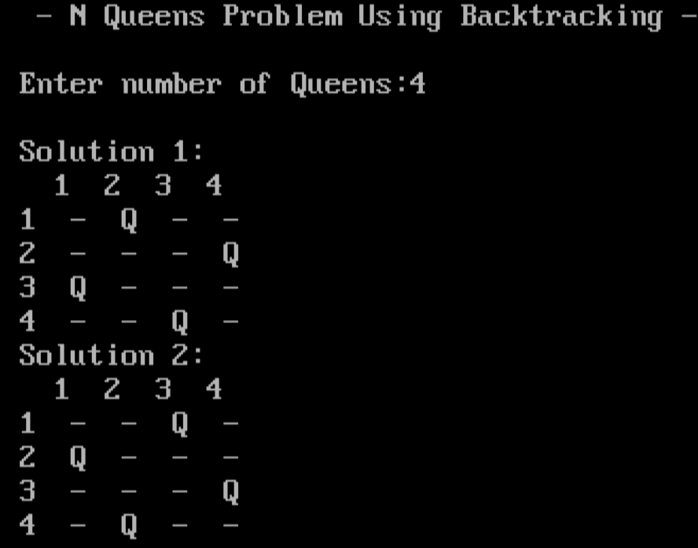
Application | Local search or constraint programming is useful to solve the problems like creating a solution which fulfills some condition.
Outcome: | Successfully implemented N queen problem using Backtracking Strategy in C.

